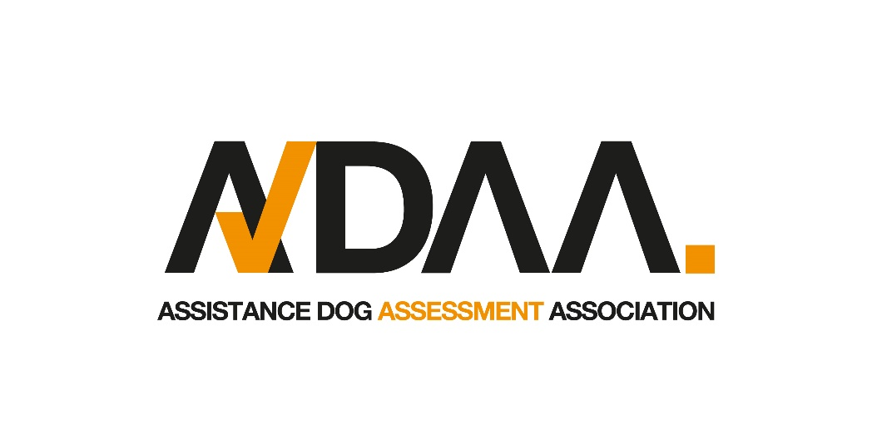

Thank you for your interest in becoming one of The ADAA’s approved assessors.
We would be very grateful if you would take the time to complete the following questionnaire and return this to us.
There are no right or wrong answers, as we are looking for information to help us gauge your personal experience, approaches and attitudes to assistance dog training. The answers you give are only intended to provide information for further discussion.
Feel free to add any additional information that you may feel relevant to your suitability as an assistance dog assessor.

Please note: This questionnaire is not a formal application. Separate documentation for recording personal details, reference requests etc. will be provided. DBS checks are also undertaken for any appointed person in line with our Safeguarding Vulnerable Adults Policy.

As part of the assessment process our assessor who utilise an assistance dog are asked to make their own reasonable adjustments to enable them to carry out the assessment of ADAA applicants.
By agreeing to be an assessor on behalf of the ADAA you are agreeing to carry out the assessment of applicants without your assistance dog being present for the test.
If you are unable to make your own adjustments to facilitate this, please reach out to us.

Name:

Contact Number:

Address:

Distance willing to travel for assessments:

Do you hold a current driving licence:

Current employment details

Describe your experience training or working with assistance dogs.

Please list any formal qualifications

Please list any organisational memberships you have (Only those current)

Who, in the field of dog training, do you admire the most?

List the last 3 seminars or training courses you attended, including dates.

List your favourite publications relating to the fields of training and behaviour.

Briefly describe what you would be looking for when you assess a ‘settle’.

Briefly describe what you consider a suitable recall demonstration for an assistance dog.

Briefly describe how you would teach loose lead walking to someone with a physical disability (describe the equipment you would use and why.)

List 5 reasons you feel you might stop an assessment in progress.

Please feel free to add any information you feel will assist your application.

Thank you for taking the time to complete this questionnaire.
Please return this to us via email if possible (scanned copies are accepted) at info@theadaa.org or post a copy to: 14 Oakcroft, Stagsden, Bedford, Bedfordshire, MK43 8SF or email a copy to

